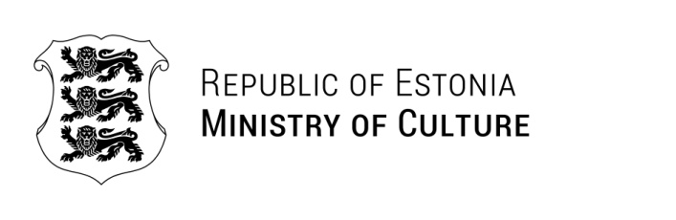

TO WHOM IT MAY CONCERN
 | 15.08.2025 | No 5-8/842-1

Certificate

This is to certify that as of May 5th, 2025, Mrs Laura Kipper (personal ID no 47710186511) is serving as the Director of the Estonian National Museum based on a contract concluded with the Minister of Culture of the Republic of Estonia.

Yours sincerely,

Saale Kaing
Human Recourses Manager

